Unit 2 SS8H1b&c Exploration/Colonization “I Can” Name _____________________ Class ___ AC
SS8H1 The student will evaluate the development of Native American cultures and the impact of European exploration and settlement on the Native American cultures in Georgia.
b. Evaluate the impact of European contact on Native American cultures; include Spanish missions along the barrier islands, and the explorations of Hernando DeSoto.
c. Explain reasons for European exploration and settlement of North America, with emphasis on the interests of the French, Spanish, and British in the southeastern area.

- Which European countries were the major colonizers of the New World? 1.
- How did Spanish missions along the barrier islands impact Native American culture? 2.
- What was the impact of Hernando DeSoto’s exploration on Native Americans? 3.
- How did mercantilism help England’s economy? 4.
- Describe geographic differences among England’s New England, Middle, and Southern Colonies. 5.

**For the 3 boxes at the end of each question, use red in the first box if you are not proficient in your understanding, use yellow in the second box if you feel you have some understanding, or use green in the third box if you have mastered what the question is asking. Work your way to green to say “I can”!!

I Can Statements:

- I can evaluate the impact of Europeans exploration and contact on the Native American cultures in Georgia.

- I can evaluate the impact of Spanish missions along the barrier islands on Native Americans.

- I can evaluate the impact of the explorations of Hernando DeSoto on Native Americans.

- I can explain reasons for European exploration and settlement of North America.

- I can compare and contrast the interests of the French, Spanish, and British in the southeastern area of North America

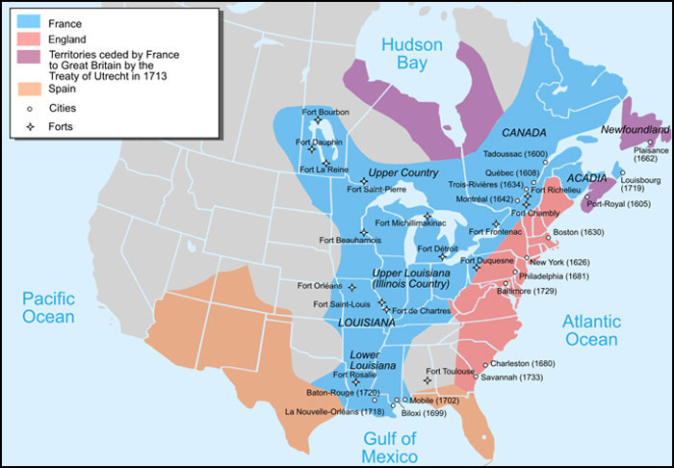
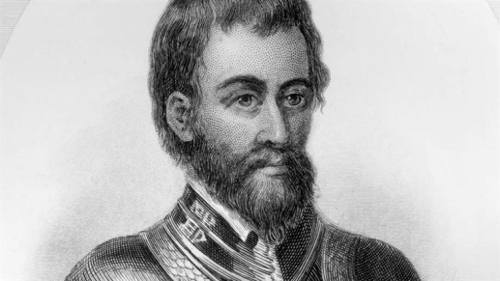
USA Test Prep Review
Hernando De Soto

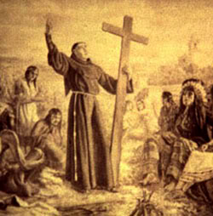
Standard Date completed
SS8H1__ _________
SS8H1__ _________
SS8H1__ _________
SS8H1__ _________
SS8H1__ _________
Spanish Missions
SS8H1__ _________
French, Spanish and British fought to control Southeastern area

