SS8H2 Colonial Georgia “I Can” Statements Name _____________________ Class ___ AC
SS8H2 The student will analyze the colonial period of Georgia’s history.
a. Explain the importance of James Oglethorpe, the Charter of 1732, reasons for settlement (charity, economics, and defense), Tomochichi, Mary Musgrove, and the city of Savannah.
b. Evaluate the Trustee Period of Georgia’s colonial history, emphasizing the role of the Salzburgers, Highland Scots, malcontents, and the Spanish threat from Florida
c. Explain the development of Georgia as a royal colony with regard to land ownership, slavery, government, and the impact of the royal governors.

- Why is Oglethorpe important? 1.
- Why was Oglethorpe interested in helping the “worthy poor”? 2.
- Which groups were not allowed in the Georgia colony? 3.
- How was Georgia a buffer for colonists in South Carolina? 4.
- What was the Charter of 1732? 5.
- What roles did Mary Musgrove and Tomochichi play in Georgia’s founding? 6.
- Name the location of Georgia’s first settlement. What is it now called? 7.
- Describe the original design for the city of Savannah. 8.
- Who were the malcontents? 9.
- Who were the Salzburgers and the Highland Scots? Where did they settle? 10.
- Why were the Spanish seen as a threat in nearby Florida? 11.
- Who were Georgia’s 3 royal governors? 12.
- Explain the changes that took place when Georgia became a Royal Colony instead of a Trustee Colony.

**For the 3 boxes at the end of each question, use red in the first box if you are not proficient in your understanding, use yellow in the second box if you feel you have some understanding, or use green in the third box if you have mastered what the question is asking. Work your way to green to say “I can”!!

I Can Statements:

- I can explain the importance of James Oglethorpe.
- I can explain the importance of Tomochichi and Mary Musgrove to the city of Savannah.
- I can explain the importance of the Charter of 1732 and England’s reasons for settling Georgia.
- I can evaluate the Trustee Period of Georgia.
- I can emphasize the role of Salzburgers, Highland Scots, and malcontents.
- I can explain the development of Georgia as a royal colony with regard to land ownership, slavery and government.
- I can explain the impact of the royal governors.

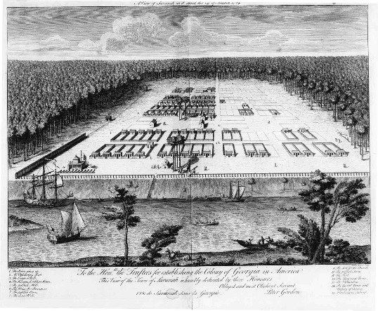
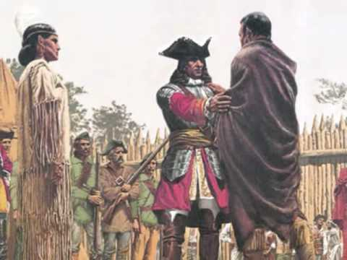

USA Test Prep Review
Standard Date completed
SS8H2__ _________
SS8H2__ _________
SS8H2__ _________
Mary Musgrove interpreting for Tomochichi and James Oglethorpe at Yamacraw Bluff.
SS8H2__ _________

